***AIML CLIENT REPORT SUBMISSION***

***Client 1: Health-Conscious Individual***

1. Q: What types of diets does the chatbot support?

A: The chatbot supports vegetarian, vegan, gluten-free, and low-carb diets.

2. Q: Can I get calorie counts for each recipe?

A: Yes, each recipe recommendation includes estimated calorie counts.

3. Q: How does the chatbot determine my dietary preferences?

A: You specify your dietary preference at the beginning of the conversation.

4. Q: Can I ask for recipes for specific ingredients I have at home?

A: Currently, the chatbot does not support ingredient-specific queries, but future enhancements may include this feature.

5. Q: Will I get meal plans for multiple days?

A: Yes, you can request meal plans for any number of days, and the chatbot will provide a structured plan.

6. Q: What happens if I choose an invalid dietary preference?

A: The chatbot will prompt you to enter a valid preference again.

7. Q: How many recipes will the chatbot suggest?

A: The chatbot provides a list of two to three recipes for the selected dietary preference.

8. Q: Can I request recipes for special occasions?

A: The current version does not support special occasion queries, but this feature can be considered for future updates.

9. Q: Does the chatbot provide grocery lists?

A: No, the current version does not generate grocery lists, but this feature is planned for future enhancements.

10. Q: How does the chatbot handle dietary restrictions?

A: The chatbot will only recommend recipes that align with the dietary preferences you specify.

***Client 2: Busy Professional***

1. Q: How quickly can I get recipe recommendations?

A: The chatbot provides recommendations almost instantly after you specify your dietary preference.

2 Q: Can I save my dietary preferences for future sessions?

A: Currently, the chatbot does not save preferences, but future versions may include user profiles.

3. Q: Is there a limit to how many recipes I can request?

A: There’s no limit, but the chatbot will only display a few options at a time for clarity.

4. Q: How often are recipes updated?

A: The current version uses a static dataset, but future updates could integrate real-time recipe APIs for more options.

5. Q: Can I request meal plans for a specific cuisine?

A: The current version does not support cuisine-specific meal plans, but this feature can be considered for future development.

6. Q: Does the chatbot provide cooking instructions?

A: No, the chatbot currently only provides recipes with ingredients and calorie counts.

7. Q: Can I get suggestions for breakfast, lunch, and dinner separately?

A: The chatbot provides meal plans but does not currently categorize recipes by meal type.

8. Q: How can I access the chatbot?

A: You can run the chatbot locally using Python in your terminal or command prompt.

9. Q: Is there a mobile version of the chatbot?

A: The current version is a command-line interface, but a mobile app could be developed in the future.

10. Q: How can I provide feedback on the chatbot?

A: Feedback can be shared through email or a feedback form once the chatbot is deployed.

***Client 3: Nutritionist***

1. Q: Can I use this chatbot for my clients?

A: Yes, the chatbot can be utilized by nutritionists to provide personalized meal recommendations to their clients.

2. Q: How accurate are the calorie counts provided?

A: The calorie counts are estimated based on standard values for the ingredients used in the recipes.

3. Q: Does the chatbot take into account food allergies?

A: Currently, the chatbot does not handle food allergies, but this can be an important feature for future updates.

4. Q: Can I suggest new recipes for the chatbot to include?

A: Yes, user suggestions for new recipes are welcome and can be considered for future updates.

5. Q: Is there a limit to how many dietary preferences I can input?

A: You can only choose one dietary preference at a time, but you can run the chatbot multiple times for different preferences.

6. Q: Can the chatbot assist with meal portion sizes?

A: The current version does not provide portion size recommendations, but this is a valuable feature for future iterations.

7. Q: How does the chatbot ensure variety in meal plans?

A: The chatbot uses a round-robin method to cycle through recipes for multi-day meal plans.

8. Q: Is there a way to track clients’ adherence to the meal plans?

A: The chatbot does not currently track adherence, but this feature could be integrated in future versions.

9. Q: How can I provide nutrition education to clients using this chatbot?

A: You can guide clients to use the chatbot for meal planning and recipe suggestions while supplementing it with your nutrition education.

10. Q: Will there be updates to enhance the chatbot's capabilities?

A: Yes, there are plans to integrate more features and improve user experience based on feedback and advancements in technology.

***Client 4: Culinary Enthusiast***

1. Q: Can I find gourmet recipes using this chatbot?

A: The current dataset focuses on basic recipes, but gourmet recipes could be added in future updates.

2. Q: How creative can the meal plans get?

A: The current version uses a limited set of recipes, but creativity can be enhanced with more diverse recipe options.

3. Q: Can I customize recipes suggested by the chatbot?

A: The chatbot does not currently allow for recipe customization, but this feature could be considered for future development.

4. Q: Does the chatbot offer seasonal recipes?

A: The current version does not categorize recipes by season, but this could be a beneficial enhancement for the future.

5. Q: How user-friendly is the chatbot interface?

A: The interface is straightforward and designed for easy navigation through simple text prompts.

6. Q: Can I ask for recipes from specific cuisines?

A: Currently, the chatbot does not support cuisine-specific queries, but this feature is planned for future updates.

7. Q: Is there a community or forum where I can share my experiences?

A: Currently, there’s no dedicated community, but feedback can be provided directly to the developers.

8. Q: Will the chatbot be able to suggest wine pairings with meals in the future?

A: This feature could be a valuable enhancement for future versions of the chatbot.

9. Q: Can I interact with the chatbot using voice commands?

A: The current version operates via text input, but integrating voice recognition could be explored for future enhancements.

10. Q: How can I contribute recipes to the chatbot?

A: You can submit recipes through a feedback channel, and they may be considered for inclusion in future updates.

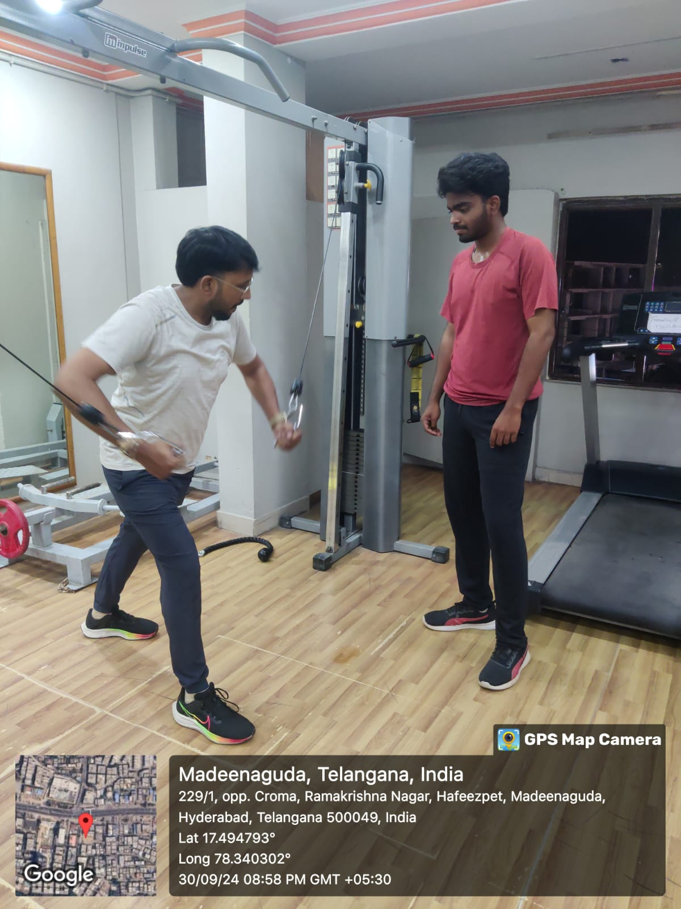**Geotag Photos:-**

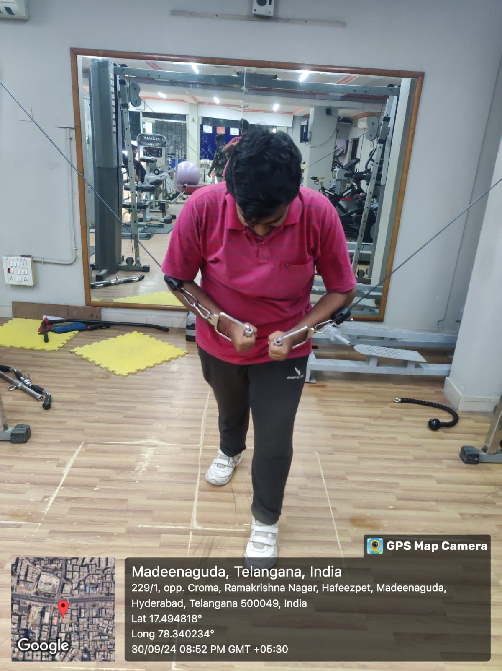

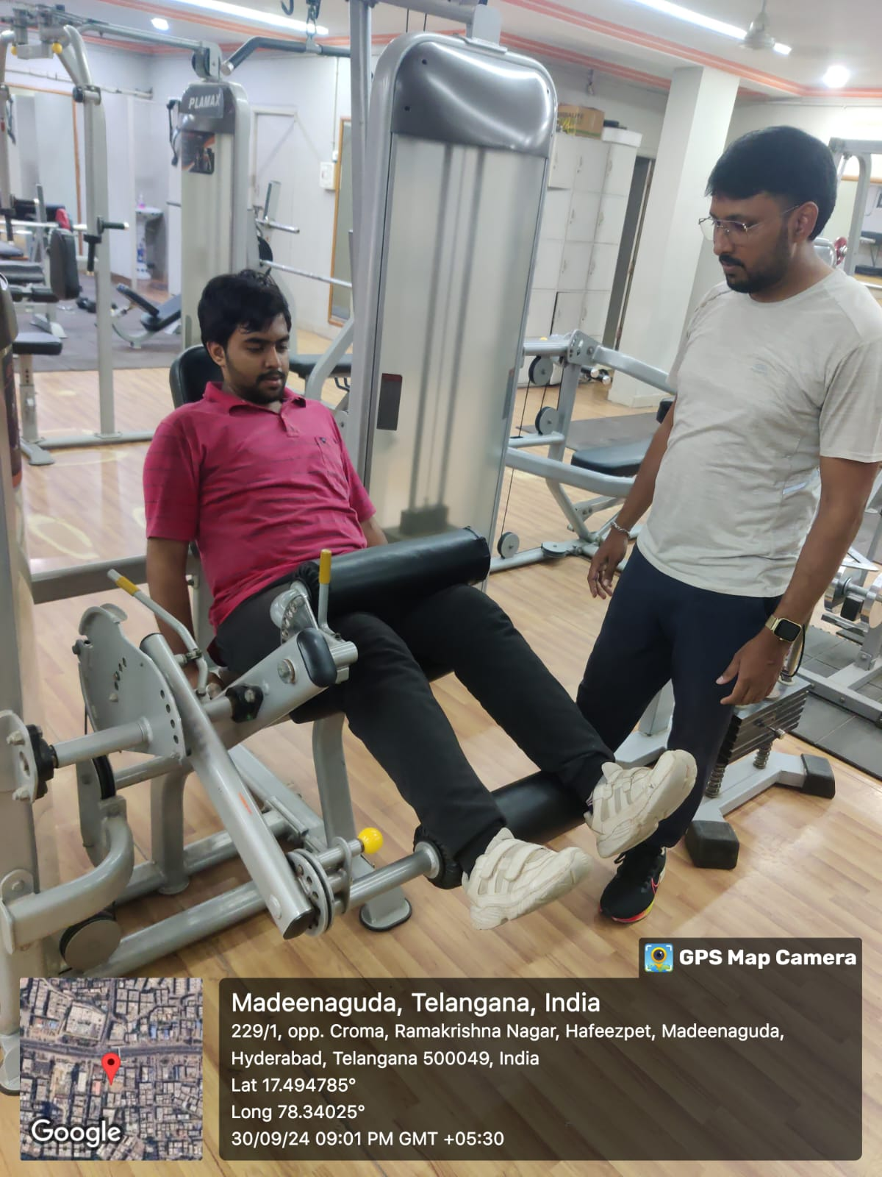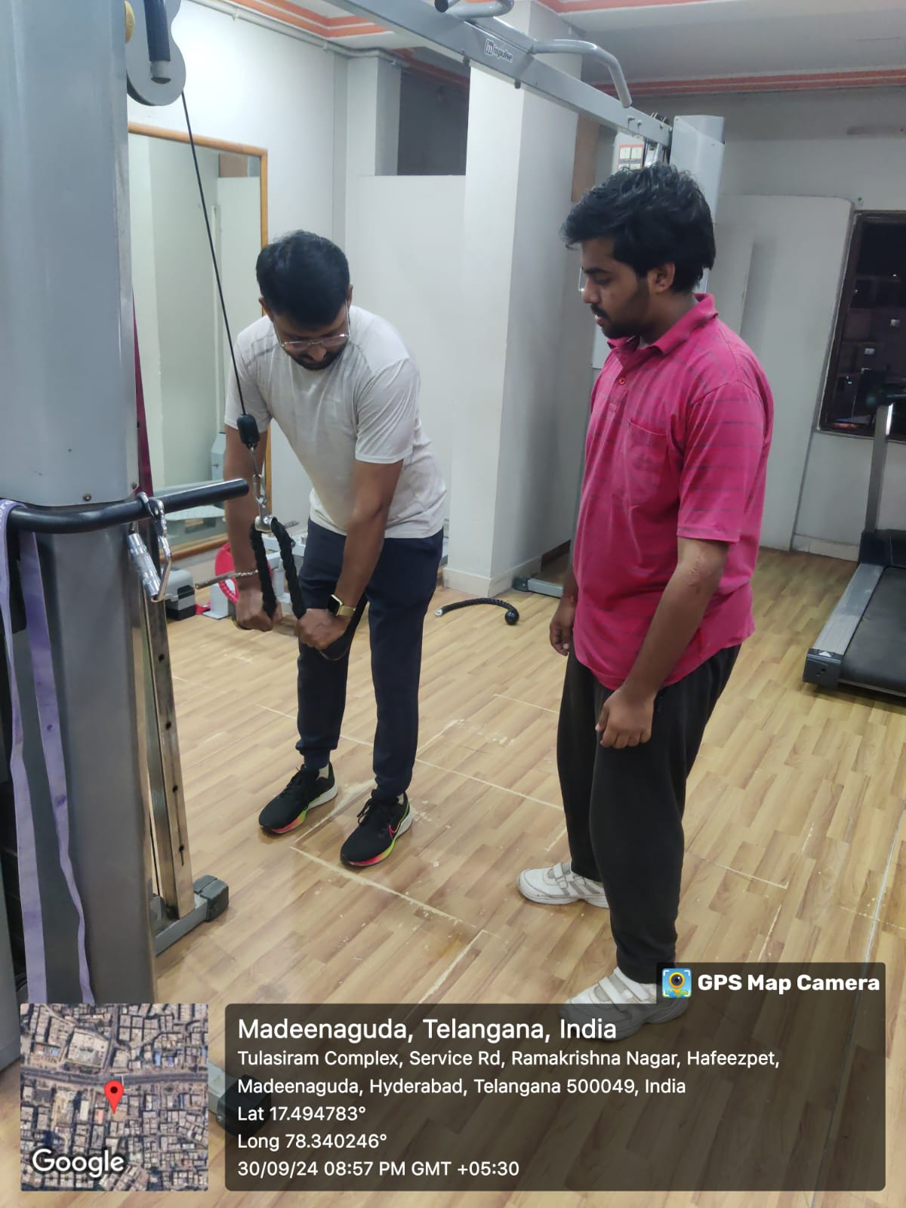

**Team Members:-**

T Varshtih Swamy – 2320030196

T Sai Harsha – 2320030308

B Sri Hari - 2320030300